**ServiceNow TestCase**

Step1: Load ServiceNow application :(example: <https://dev113545.service-now.com>)

Step2: Enter username that you had created using the given steps in the notepad

Step3: Enter password that you had created using the given steps in the notepad

Step4: Click Login

Step5: Search “incident “ Filter Navigator

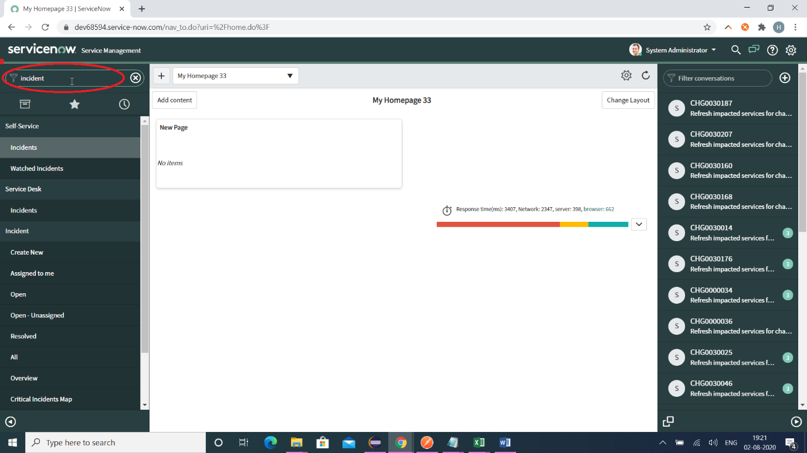

Step6: Click “All”

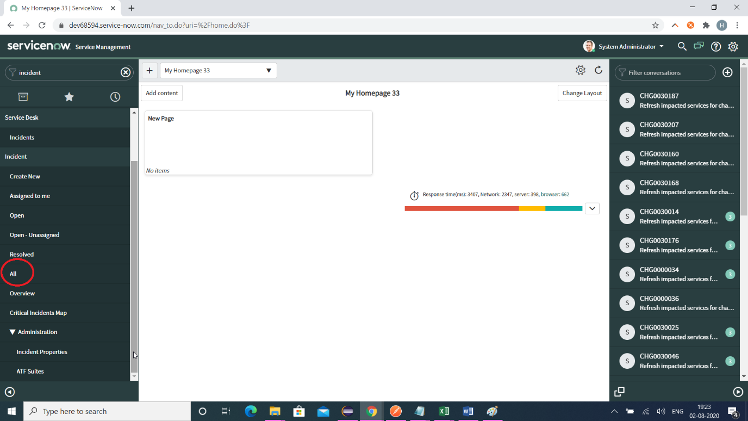

Step7: Click New button

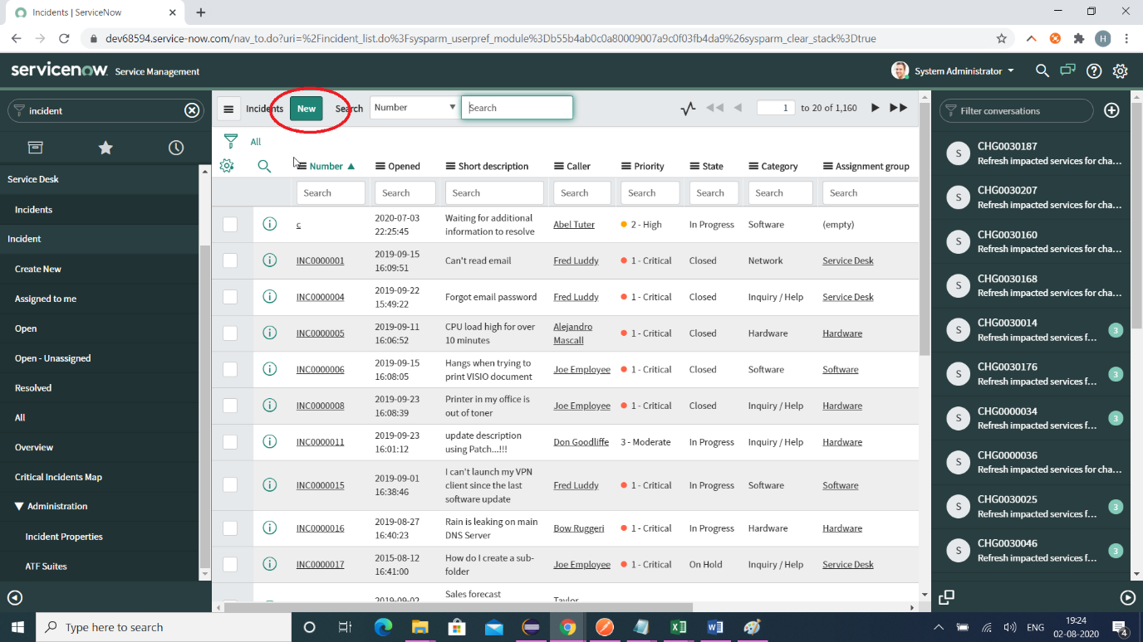

Step8: Select a value for Caller and Enter value for short_description

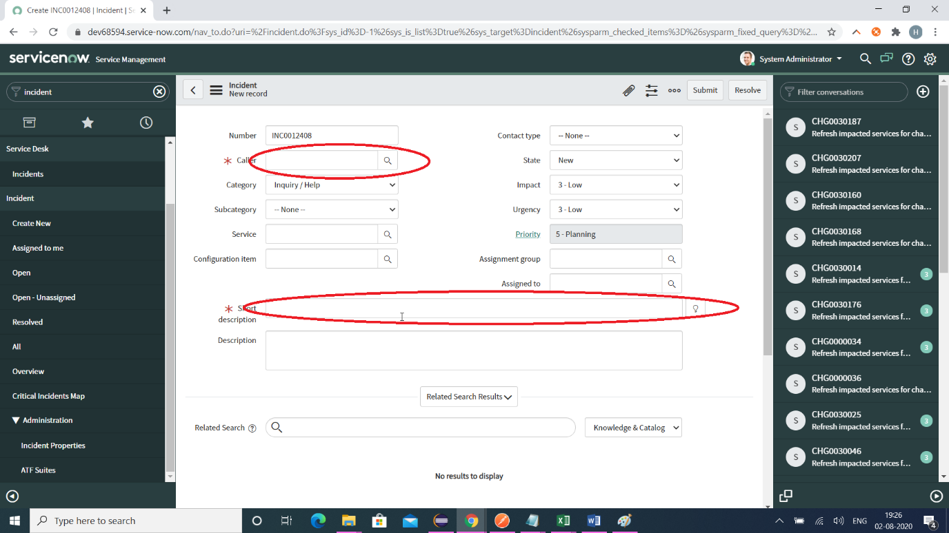

Step9: Read the incident number and save it a variable

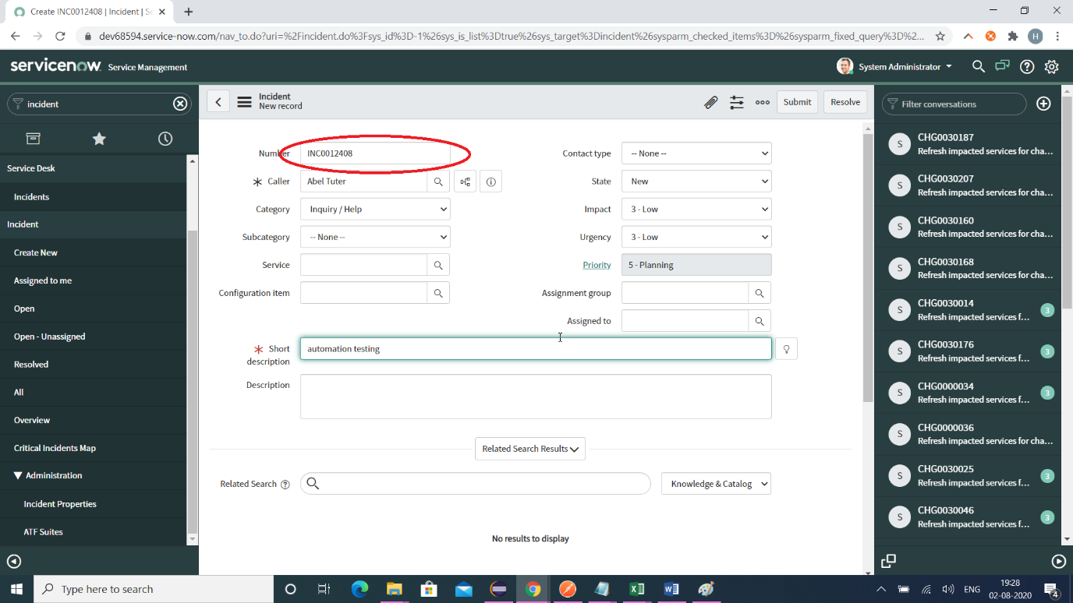

Step10: Click on Submit button

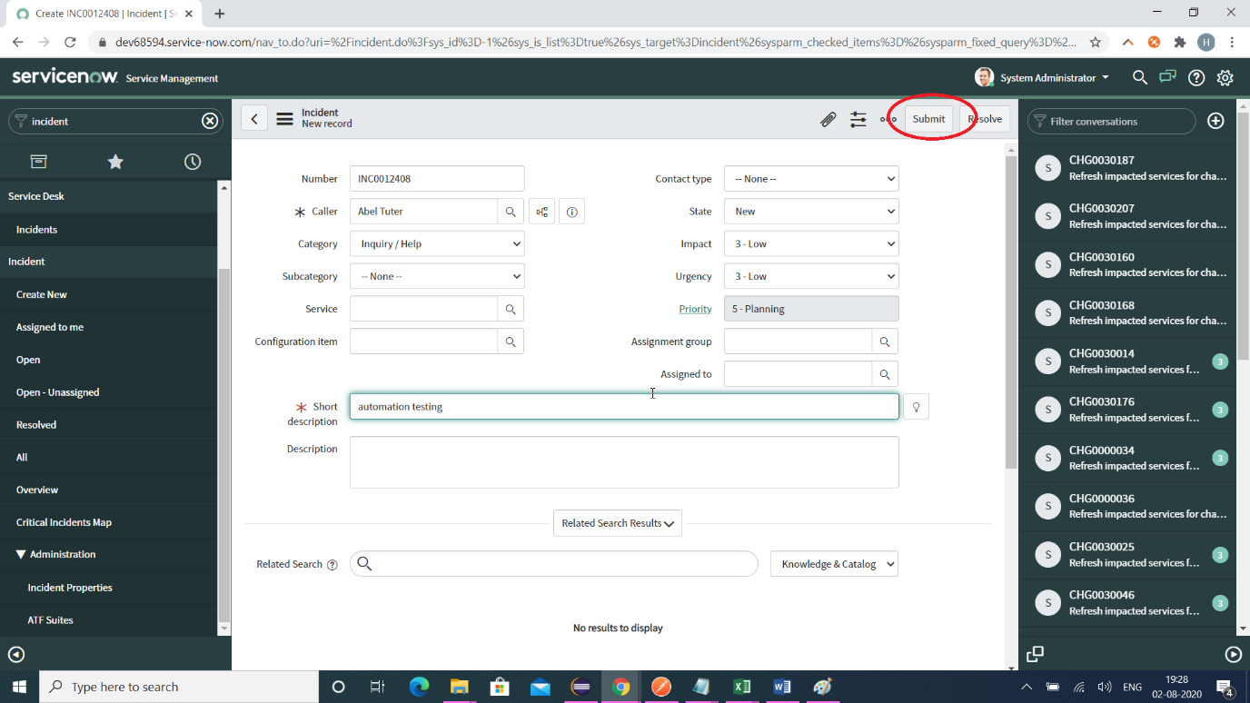

Step 11: Search the same incident number in the next search screen as below

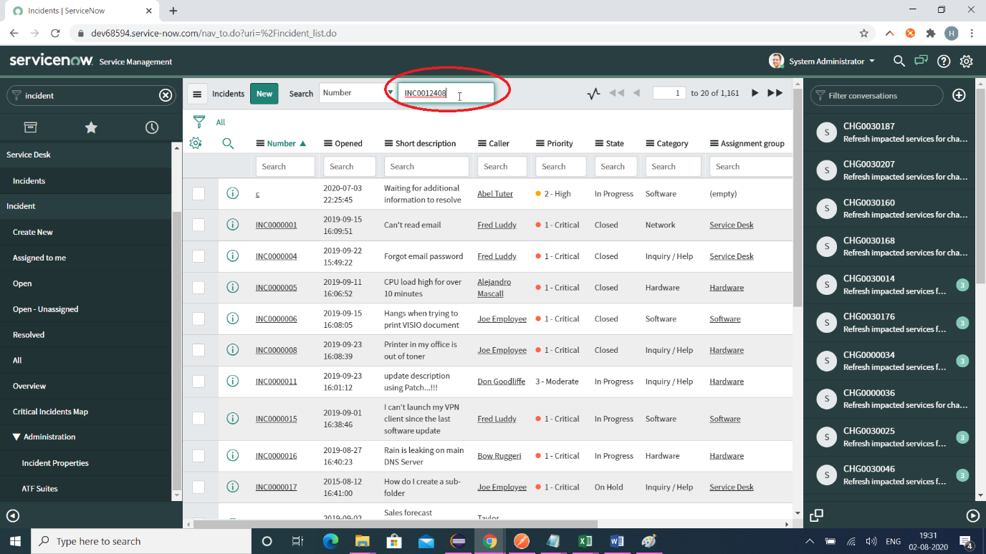

Step12: Verify the incident is created successful

